Notification Advice: Information to be communicated to NRFC members, community, staff/volunteers and all users of the clubroom facility. |  | Person initiating this notification | Action.
1 | What to do in case of a Fire.  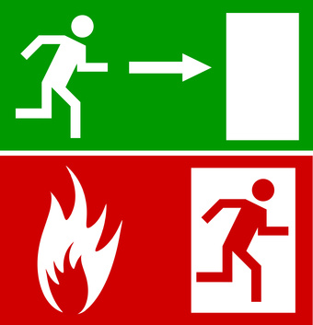 | Grant Crossett  Operations Coordinator.  Date: 14th July 2016. | Posted to notice boards.
2 | Remain calm.  Verbally warn people in the immediate vicinity.  Activate the fire alarm and ring 111.  If you are able to safely put the fire out do so and then notify the Fire Service that this has been done.  Follow the advise of any Fire safety warden.  Look for the exit signs.  Make your way out of the first available safe fire exit.  Look to assist others on your way out.  At all times try to walk do not run.  Once outside assemble by the Trafalgar Park Ticket booths at the corner of Trafalgar Park Lane and Trafalgar Street.  If you exit by the doors facing the Marist club you are to assemble as above. However if your way to the assembly point is blocked by fire you are to assemble in the carpark at the rear of the Tasman Rugby Union Building.  At all times Fire Wardens will assist you.  The Chief Fire Warden is to ensure (without putting themselves at risk) that all the building has been checked and that no people have been left behind.  Once you are outside do not attempt to re-enter the building.  A roll call and a list of names will be taken at your assembly point.  Once you are safe at the assembly point assess your situation then look to help others.

